Kyle Finter Assignment 1

Risk_serial.py

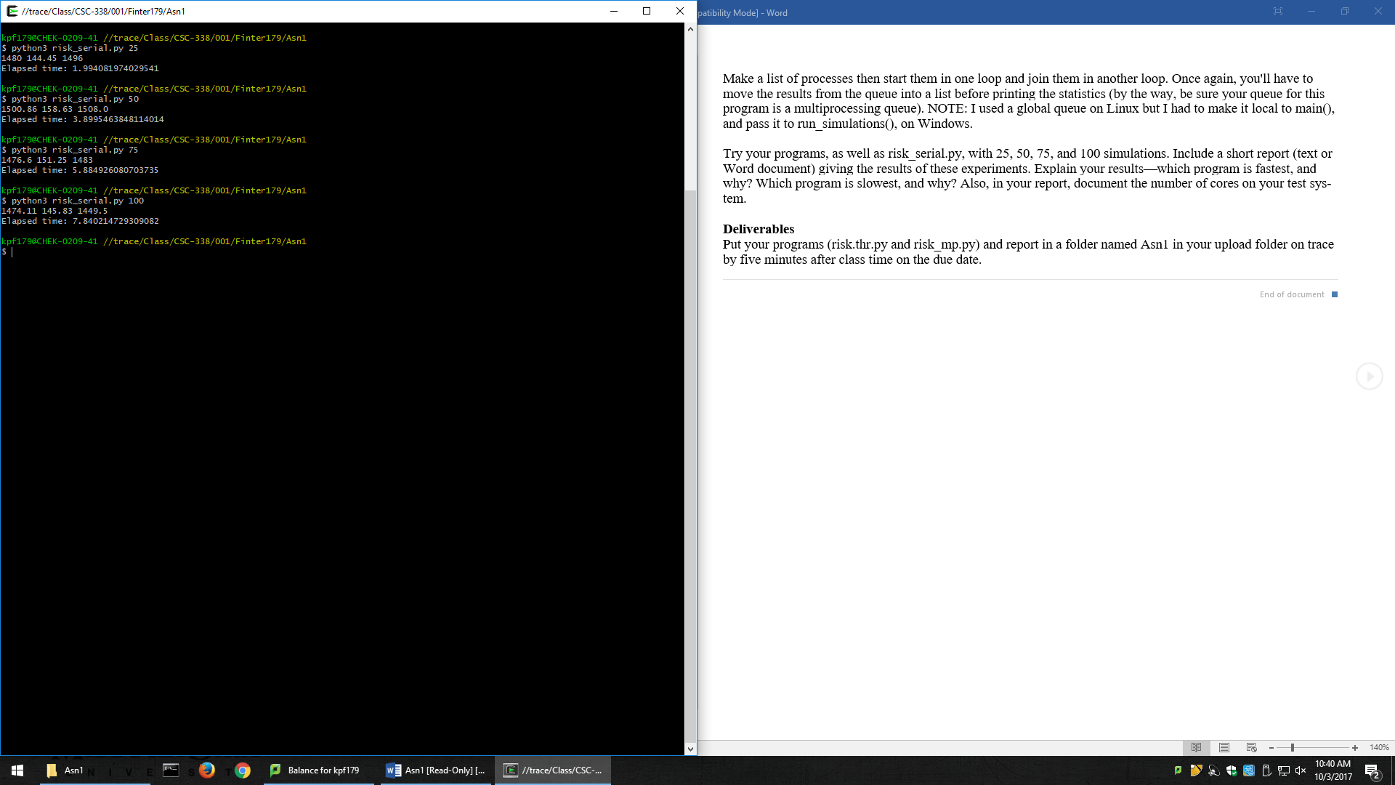

Risk_thr.py

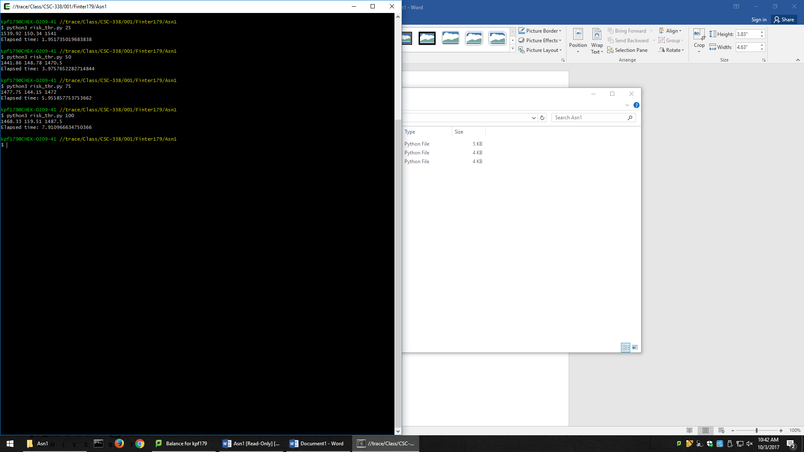

Risk_mp.py

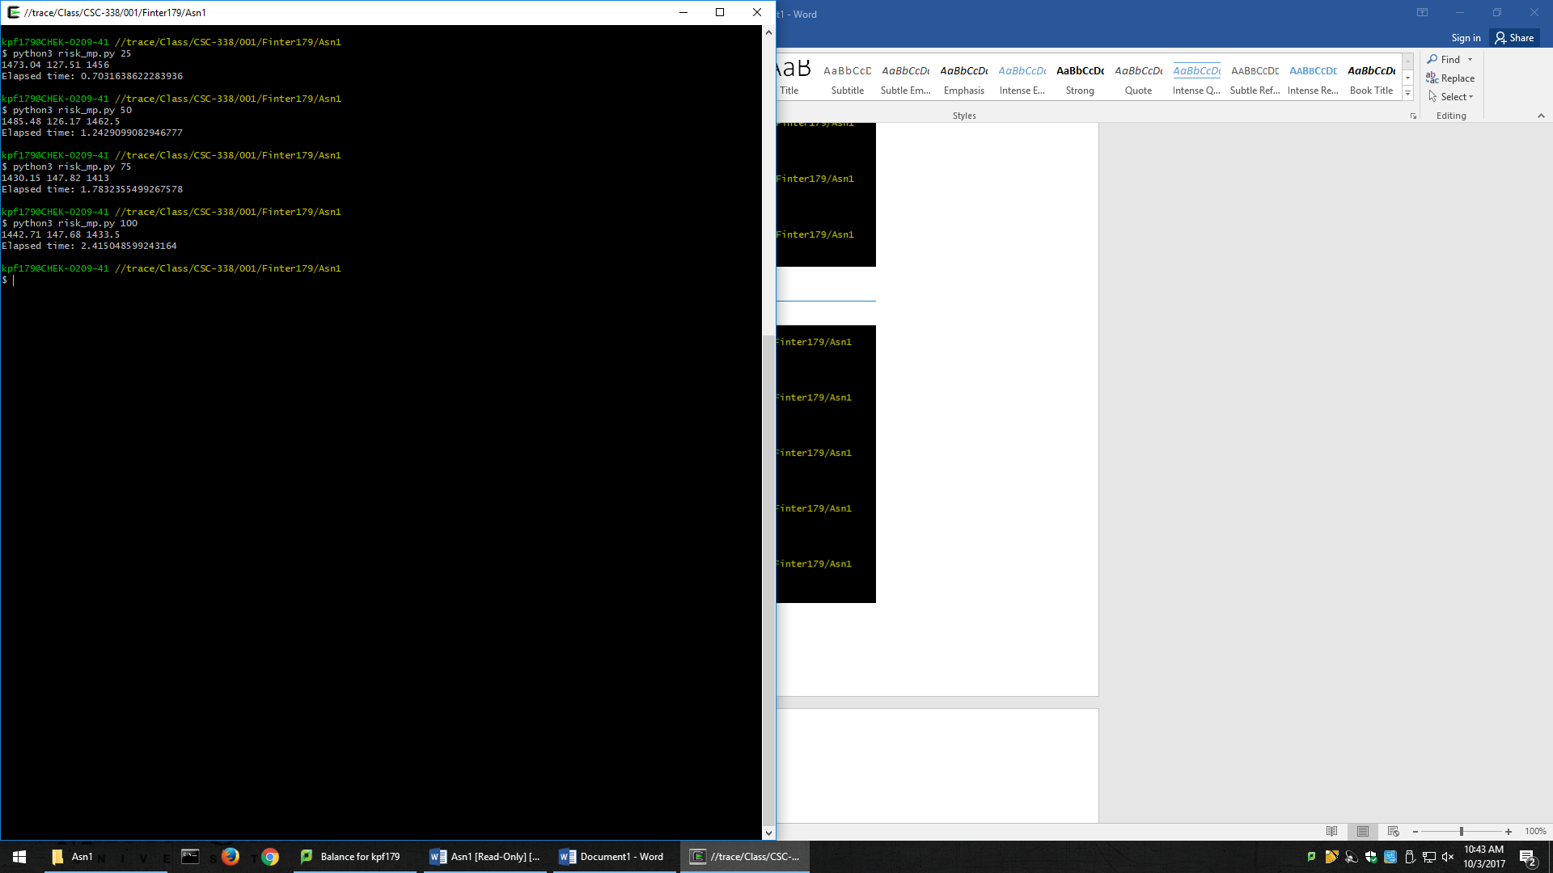

My computer had 4 cores. The multiprocess program was the fastest by far. It could accomplish the same amount of work at over 3 times the speed. I think this was the case because each process was able to work at the same time as opposed to each thread having to wait to grab stuff from the queue. Risk Serial was around the same speed as Risk Thread. I think it was because of how the threads were being delegated. Each thread taking only had one simulation. So any speed increase was offset by the amount of time and overhead needed to set up the thread.